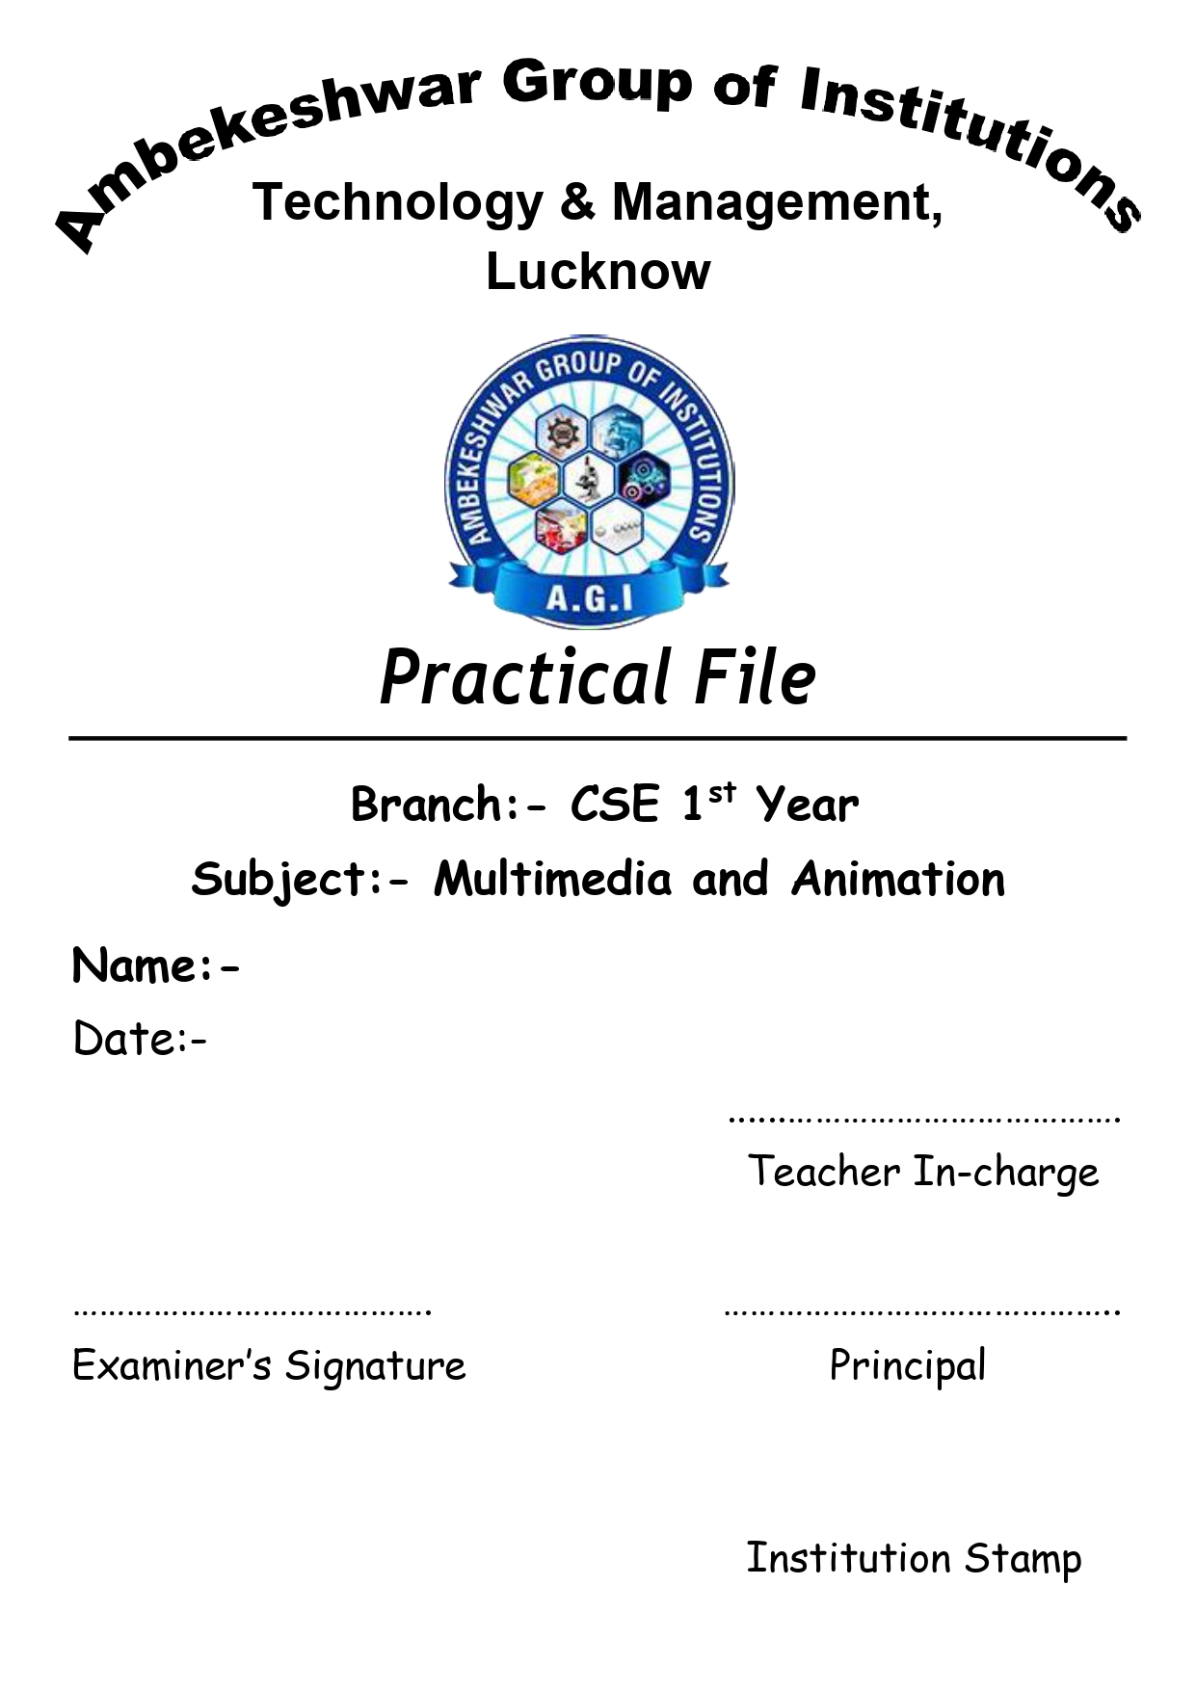

**Suraj Arya**

**Practical No:1**

**AIM-Transporting audio and video files.**

**Transporting audio**

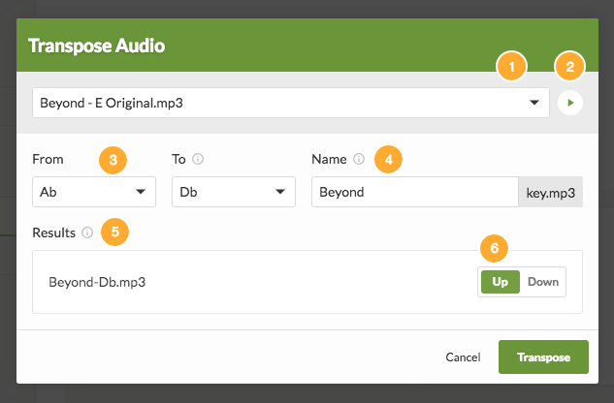

1. Use the dropdown to select a file to transpose. Any transposable audio files (mp3, m4a, aac) attached anywhere on the current arrangement will be options.
2. Listen to the selected file if you need to determine its original key.
3. Choose the original key of the selected file, and then select which keys you'd like your file in. If you choose a key that does not yet exist on your arrangement, it will be created.
4. If you want the file name of all your transposed files to be different than your original, edit the base file name.
5. See which files will be created based on the To key and Name you've specified.
6. Select which direction each song file will be transposed to. The closest direction, which normally provides the best results, is chosen automatically.

Click Transpose, and your files will go into the queue to transpose.

As your files transpose, you'll see progress at the top of the arrangement tab. When they finish, they'll show up in your file lists.

**Transporting Video**

Publish and remotely view a video feed

The quickest way to have a Video Transport experience is via the Web Preview:

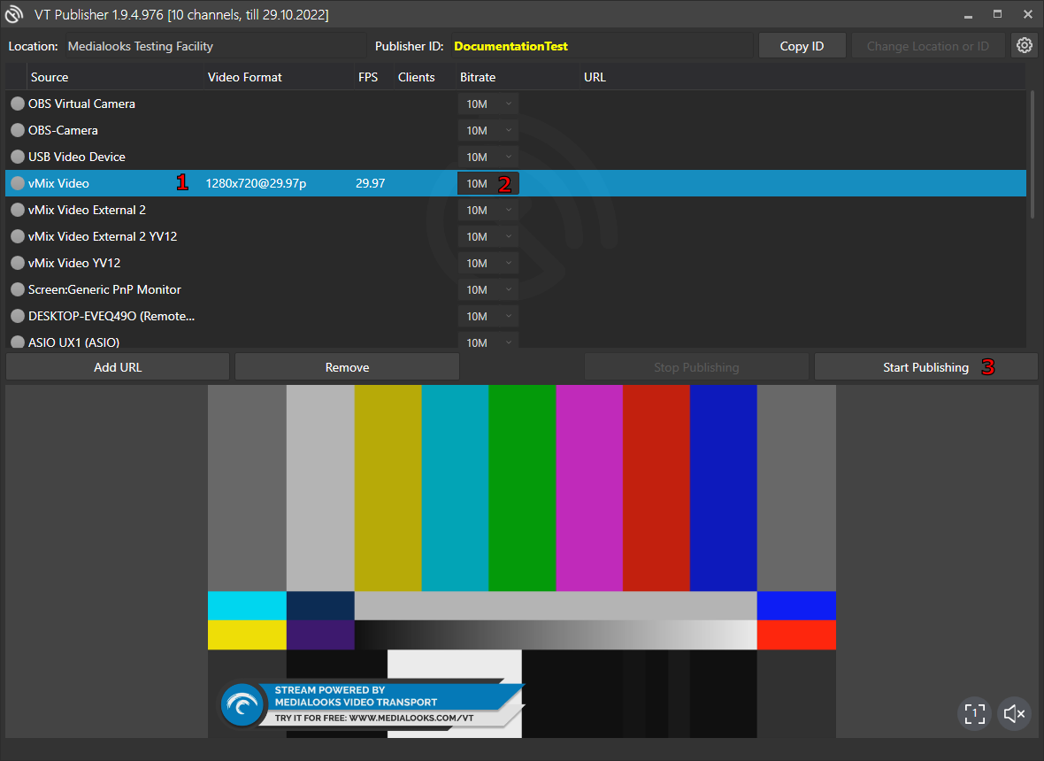

* Run VT Publisher.
* Select the source you wish to publish from the list of available sources (1). Once selected, the preview of the source will start and its parameters (Video Format, FPS) will be shown.
* To start publishing, choose the desired bitrate (2) and hit "Start Publishing" (3).
* Copy the link from the "URL" tab (4) and paste it into a browser.

**Practical No:2**

**AIM-Installing and use of various multimedia devices**.

Scanner - Digital camera, web camera - Mike and speakers Touch screen - Plotter and printers - DVD

**Install Scanner**

Install or add a local scanner. In most cases, all you have to do to set up a scanner is to connect it to your device. Plug the USB cable from your scanner into an available USB port on your device, and turn the scanner on.

In most cases, all you have to do to set up a scanner is to connect it to your device. Plug the USB cable from your scanner into an available USB port on your device, and turn the scanner on. If that doesn't work, here's a way to do it manually.

1. Select **Start > Settings > Devices > Printers & scanners** or use the following button**.**

**Open the Printers and Scanners Settings**

1. Select **Add a printer or scanner**. Wait for it to find nearby scanners, then choose the one you want to use and select **Add device.**
2. If your scanner is included in a multifunction or All-In-One printer, you may only see the name of your printer. To see your scanner, under **Printers & scanners,** select your installed printer, select **Manage**, and then choose your scanner.

**Uses of Scanner**

* Scan Document File
* Scan Diagram & Picture
* Scan Book
* Scan Story Book
* Scan Graphics & Banners

**Install Digital Camera**

1. Close any programs that are running.
2. Place the Canon Digital Camera Solution Disk in the CD-ROM drive. Setup starts automatically.
3. If setup does not automatically start, click on the Start button on the Windows taskbar and choose Run. Type X:\Setup (where "X" is the drive letter of your CD-ROM drive). Click **OK**.
4. Click **Software Installation**.
5. Select the install location and click **Next**.
6. Select the software you wish to install and follow the on-screen instructions to proceed.
7. Click **Finish** when the installation is complete and the installer panel appears again.

**Uses of Digital Camera**

* Diagnosis
* Treatment-planning
* Image-editing
* Case presentation
* Insurance reimbursement
* Lab communication
* Specialist communication
* Internal marketing
* External marketing
* Accreditation and Fellowship

**Install Web Camera**

webcams are universal, meaning they work on almost any computer. Follow the steps below to connect and install a webcam on your computer.

1. Turn on your computer and make sure the operating system is loaded.
2. Most webcams have a USB cable connected to them. Plug the USB cable into an available USB port on your computer. USB ports are on the back of the computer or the sides of a laptop.
3. Newer operating systems, like Windows 8 and Windows 10, should recognize the webcam as connected. The drivers are usually installed automatically, allowing the computer to use the webcam.
4. If your webcam came with a CD containing software, you can install that software to add additional features for the webcam.
5. The webcam needs to be placed in front of you, and near the same height as your face while sitting. The best location to mount the webcam is at the top of your computer monitor. Most webcams sit on top of a monitor, having an adjustable clamp that braces itself against the back of the monitor to secure the webcam. Place the webcam on top of the monitor and adjust the clamp as desired, When finished, the webcam should be pointed at your face.

**Uses of Web Camera**

* Work Efficiently
* Maintain Personal Relationships
* Attend a Lecture or Study Online
* Wide Applications

**Install Mike and speakers**

1. Make sure your microphone is connected to your PC.
2. Select Start Windows logo Start button > Settings Gear-shaped Settings icon > System > Sound.
3. In Sound settings, go to Input > Choose your Input device, and then select the microphone or recording device you want to us.

To install a new **Speakers,** follow these steps:

1. Take the speakers off from the packaging. Speakers usually come in two, unless a subwoofer is included.
2. Figure out which is the left and the right speaker. Set them appropriately where you would like to place them on your desk. Controls should be within reach from where you are sitting. This way you can easily turn up or turn down the volume.
3. Shut down the computer.
4. Connect the speakers to the computer sound card. Make sure that the speaker wire is plugged in the right port at the back of the PC. This may seem fairly easy, using common sense but some people plug it to the microphone plug and complain that their speakers do not work. Sometimes, it is only a matter of matching the color of the jack on the speaker cables with that of the input on the computer sound card. You may also look for the input jack with a speaker or headphone icon beside it. At the back of the speakers, it may show 3-4 different audio inputs such as subwoofer out, AC in or left speaker. It may also show different names according to the manufacturer.
5. Speakers using an external power supply such as a battery have a line-out connection that needs to be connected to the right jack. Connect the speakers to its power source and depending on the speakers you have purchased, the power cable may come hard- wired to the speakers or needs to be plugged in.
6. Start up your computer and turn on the speakers.
7. Test the sound connection by opening any audio or MP3 file in the PC. You can adjust the speaker volume to a comfortable level on the application playing the file.
8. You can also check volume settings in Sound and Audio Devices under Control Panel. Make sure all the lines are connected properly to the computer also. Check the items on the Master Volume screen to configure volume levels for bass line, wave, CDs, and the microphone volume.

**Uses Mike**

* It is used for voice recording.
* It offers users the option of voice recognition.
* It allows users to record sound of musical instruments.
* It enables users to online chatting.
* It allows us for VoIP (Voice over internet protocol).
* It is also used for Computer gaming.
* Furthermore, it can record voice for singing, podcasts, and dictation.

**Uses Speakers**

* It enhances Computer sound.
* It is used for entertainment while working.
* It enhances gaming performance.

**Install Touch Screen**

Download the correct drivers for your system. Thereafter, double-click the downloaded file and follow the on-screen instructions to install the driver. Do not forget to restart the system to apply changes to the Windows touch screen should now be working fine. We hope we were able to answer how to install the touch screen driver Windows.

**Uses Touch Screen**

* In an airplane
* Video games
* Public machines

**Install Plotter and printers**

1. Download the Windows Installer file (.exe) from the Downloads page or your email confirmation.
2. Double click the file on your computer to install it
3. Windows may tell you that it's potentially dangerous
4. Click "Run Anyway"
5. Windows will ask you where you want to install the file and to confirm the installation.
   1. Log in to your computer, connect your printer using the USB cable and click "Settings" from the start menu.
   2. Log in to your computer, connect your printer using the USB cable and click "Settings" from the start menu.
   3. When you click the "Devices" option, you will see the "Printers and scanners" located at the bottom of the Find box.
   4. Now click "Printers and scanners" and then you will see the expanded Printers and scanner option. Your next move is to click the "Add a printer or scanner." Make sure you have the internet connection which will make this process faster. Windows will now find the driver of your printer and install automatically to the Computer.
   5. If the searching finishes without installing the printer, then you will see a text below the searching option as "The printer I want isn't listed." Click that option and Windows troubleshoot automatically search and open a new tab.
   6. Now the look at the "Find a printer by other option" window and check the box "My printer is a little older, Help me find it" and click "Next".

**Uses Plotter and printers**

Uses of plotter-

* A plotter can be considered a computer printer primarily used in printing and obtaining the output of vector graphics and images with high resolutions. Plotters are capable of drawing pictures and design using a pen.
* They are also used in CAD [Computer Aided Design] and CAM [Computer Aided Machines].
* They are used in substantial engineering applications and projects.
* They are also used in designing and creating architectural plans for buildings and new constructions.
* They are used in developing diagrams and constructions maps.
* Drawing illustrations and engineering drawings with business charts are developed in plotters.
* They are primarily used in printing agencies where design and develop giant banners, signboards, signboards, and billboards.
* They are used by professionals like engineers, architects, and graphics designers.

**Uses of printer-**

* Print Text
* Print Document File
* Print Diagram & Pictures
* Print Book
* Print Story Book
* Print Graphics & Banners

**Install DVD**

1. Power down the PC completely. After the computer has safely shut down, turn off the internal power by flipping the switch on the back of the power supply and removing the AC power cord.

2. Open the computer to install the CD or DVD drive. The method for opening the case varies depending upon your computer model. Most use a panel or door on the side of the computer. Older computers may require you to remove the entire cover. Remove and set aside any screws that fasten the cover or panel to the computer case and then remove the cover.

3. Remove the drive slot cover. Most computer cases have several slots for external drives but only use a few. Any unused drive slot has a cover that prevents dust from entering the computer. Remove the 5.25-inch drive slot cover by pushing tabs either on the inside or outside of the case. Sometimes a cover might be screwed into the case.

4. Set the IDE drive mode. Most CD and DVD drives for desktop computers use the IDE interface, which allows for two devices on a single cable. Place each device on the cable into the appropriate mode. One drive is the primary, and the other drive is the secondary. One or more jumpers on the back of the drive usually handle this setting. Consult the documentation or diagrams on the drive for the location and settings.

5. Place the CD/DVD drive into the computer. The method for installing the drive varies depending on the case. The two common methods for installing a drive are either through drive rails or directly into the drive cage.

6. Attach the internal audio cable. To use CD/DVD drives to listen to music, the audio signal from the CD drive must route to the computer audio solution. Typically, a small two-wire cable with a standard connector handles this. Plug this cable into the back of the CD/DVD drive. Then, plug the other end into either a PC audio card or motherboard depending upon the computer's audio setup. Lastly, plug the cable into the connector labeled as CD Audio.

7. Attach the CD/DVD drive to the computer using an IDE cable. Usually, the drive resides secondary to the hard drive. If so, locate the free connector on the IDE ribbon cable between the computer and the hard drive, then plug it into the drive. If the drive will be on its own cable, connect the IDE cable to the motherboard and one of the other connectors of the cable into the CD/DVD drive.

8. Plug the drive into the power supply. Locate one of the 4-pin Molex connectors from the power supply and insert it into the power connector on the CD/DVD drive.

9. After you install the drive, close the computer. Replace the panel or cover to the computer case. Fasten the cover or panel to the case using the screws you set aside when you removed the cover.

10. Plug the AC cord into the power supply and flip the switch to the On position. 11. The computer system should automatically detect and use the new drive. Since CD and DVD drives are standardized, you shouldn't have to install any specific drivers. Consult the instruction manual that came with the drive for instructions for your particular operating system.

**Uses of DVD**

DVDs are widely used for storing and viewing movies and other data.

**Practical No:3**

**AIM-Using various features of Flash**

Basic features of Flash include simple vector-based drawing tools, media effects, and simple and complex interactions.

**Drawing tools**

You can create simple graphics and illustrations using Flash's drawing tools. Then Flash saves

those graphics as vector images, as opposed to the typical bitmap type of image.

The advantage of vector-based images is that they are much smaller than bitmaps. This is important in keeping animation files to a reasonable size. Flash can be used to make quick drawings to be saved as GIF files. This can be easier than using more sophisticated drawing applications.

**Media effects**

Media effects include animations, slide shows, sound or audio, and video.

**Animation**

Animation is taking an image you have created with the Flash drawing tools or that you imported into Flash and then:

* Moving that image from one place to another,
* Changing the size of the image,
* Rotating the image,
* Changing the color or brightness of the image, or
* Combinations of the above.

Also, several objects can have their own animation properties at once.

**Slideshows**

Animated slideshows that include audio and video can be made with Flash.

**Sound and Video**

You can also add sound and video to your Flash animations or movies.

**Interactions**

User interactions can be added to control the animations in Flash movies.

**Buttons**

Buttons can be clicked to perform some task like starting or stopping a movie. Buttons can also be animated on the interaction.

**Menus**

Menus are forms of buttons used for Web navigation.

**Programmed effects**

Complex interaction can be programmed through the use of the Action Script programming language. One special effect is the ability to interact with a database.

**Practical No:4**

**AIM-Using various features of Photo-shop/GIMP**

**Photoshop**

Photoshop is a photo editing and design software used by photographers, graphic designers, and web designers. You can use it for a variety of tasks such as image editing, photo manipulation, illustrations, basic animations, and more.

**Features of Photo-shop**

**Photoshop Layers**

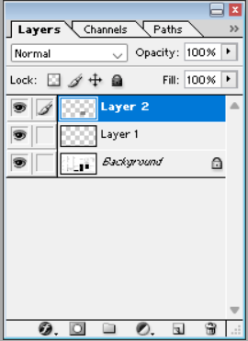

The advantage of a software-based design was beefed up with the layers palette. It extends the artists the power to gain total control over anything and everything that he is working on the document.

With Layers palette, you can draw or design various elements of your document independently in layers and stack them up as per the order of display. With this advantage, control over every single object is catered at the click of a mouse. Mistakes happen, but the effects of the mistake are limited to the part of the canvas; you can choose to work on the particular part and leave the rest of the canvas as it is. This benefit is lacking in the traditional painting method. Artists are not allowed to relax at any part of the drawing or painting once their concentration is diverted and a stroke of painting goes wrong! They are bound to change the whole canvas.

**Photoshop-Selection Tools**

Photoshop's selection tools are so handy to use that designers worldwide are addicted to the set of selection tools Photoshop offers. However, there are a bunch of competitive software and open-source software designed to give tough competition for Photoshop. Users are still stuck with Adobe's torch bearer software due to the ease its tools provide.

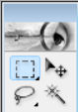

**Photoshop - Pen tool**

When we look back when multimedia software is shipped without a pen tool, we remember the software is nothing more than a bunch of color palettes. There isn't much available to do, and the creative ability is uninspiring.

Today, Photoshop cannot be imagined without a Pen tool. Though the pen tool, by nature, works for drawing paths along with the anchor points, the creative scope it provides is limitless. The tool is designed so flexibly that the designer can draw any shape or edit the existing shapes as good as he is using his bare hand. The amount of control we have through placing the anchor points in the right places is taken further with the three types of Anchor points that can allow you to draw and edit paths precisely.



**Photoshop Shapes**

In a raster-based graphic design software like Photoshop, working on an object without losing its original quality is a boon for the designers. Photoshop's shape layer does the job for us.

The outlook of the shape layers in Photoshop may be limited, but the capabilities of the feature go a step further than what we assume about it. In the traditional marquee selection tools, the selection is limited to the raster process, and in many cases, the output will result in the sharp pixilated edges, which are never good looking. But the shape layers can act as an individual object within the document with its attribute to maintain the finest quality.

A shape layer can be easily edited with the help of a pen tool or a direct selection tool and still retain its original quality. The colors inside the path can be changed anytime, and shape layers can also hold gradients and many other effects within them.

**Photoshop - Vector Mask**

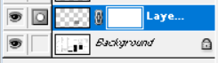

Another feature that stood at the time and lived on the top is the layer masking tool. Though there are many other tools that are introduced after the layer mask, the tool preserved its importance.

The layer masks create a masking portion of an object by using the grayscale color combination (Shades of Gray). Once the masking part is done, the area of the object under the layer mask disappears.

For fresher's, a layer mask may look like a dry and non-responsive subject. But, once the subject is grasped and they start to use the black and white colors within the masking layer thumbnail, they enjoy the ease it provides.

* There are many ways layer masks can be controlled.
* The user can directly fill the colors to mask the intended area of the object.
* It is possible to draw the masking color with the help of brush tools to gain manual control.
* A single-coloured gradient mask can also be applied for a smooth transition effect.
* Users can also play with the erase tool to have control over the filled color.
* In its recent versions of Photoshop, layer masks are further powered with the control on feathering, contrast and density.

**Photoshop-Slice Tool**

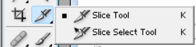

Photoshop quickly understood the need to bring a tool that helps web designers, companies, and users access a website quickly and effectively.

In an age of telephone dial-ups, there are no broad bands or Wi-Fi connections and a homepage used to take ten minutes to load. A slice tool was introduced to snip the images into slices so the loading time of a website can be mitigated to a greater extent. The tool helped the designers to a great extent and was one of the important milestones in the development of the web technology.

The slices were later used in Adobe Dreamweaver or HTML to upload them into the websites. Though there are high-end broadband connections and HTML, CSS is ruling the web markets; the Slice tool still maintains its importance in the world of the web.

**Photoshop-Retouching Tools**

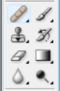

As the name suggests, Photoshop is software intended to edit raster images and is mostly used to correct images at the initial stages. As the tides of change hit the technological world, Photoshop has extended to every industry, including Print, 3D, The Web, and many more. But the name remains the same as Photoshop.

The photo editing tools that are developed over time have gained their importance in graphic designing and the photography world.

Retouching tools are an accumulation of various tools such as Stamp tool, Pattern Stamp tool, Spot Healing tool, Healing tool, Patch tool, Redeye tool and much more. Though the numbers are more, every tool has its importance. The development of retouching tools did not happen over night. Adobe was working hard identifying the problems of the photographers and finding the solutions for the problems from time to time.

The tools were proved highly helpful for the lasting problems that are facing photographers. Tools like Redeye, patch tool and healing tools came so much handy for graphic designers and photographers that they brought down the manual work for almost a hundred percent. The manual work, which was carefully done for a long time, was simply managed in a click and drag.

**Photoshop - Photoshop 3D**

The attribute that made Photoshop the number one multimedia and Graphic designing product In the world is its quick adaptability to the changing technologies. Adobe has proved this time and time again in the last two decades.

**Photoshop Adobe Creative Cloud -**



Adobe has recently introduced the creative cloud advantage, where users have access to the entire empire of Adobe software. While our point of discussion in this part is about Photoshop, I have to limit to the advantages of Photoshop within the creative cloud.

Adobe works on updates, additions and fixes of the software from time to time. Earlier, users have to wait for almost two years every time to check the updates in the latest version. But, if you are using the Photoshop CC, you can download the updates as soon as Adobe introduces it, and there is no waiting for two years.

Another popular advantage is the cloud. If you are out and not carrying your laptop and you want to access the image suddenly from your friend's laptop! An impossible thought to make before the advent of cloud computing. Now, it is possible if you choose to save your file in the Adobe cloud. Your files are still safe, and you are allowed to access your files without carrying them.

* **Photoshop has been mesmerizing us for years with incredible designing tools. We hope the software will add more feathers to its hat in the coming years. Until then, the top ten features of Photoshop will help designers in inspiring and delivering more every day.**

**GIMP**

GIMP is a multi Platform compatible image editor that means it runs on Windows, Linux and Mac OS. The software contains a number of functions that can be used to create amazing images. GIMP has features ideal for novice to advanced graphic designers. The GUI is highly customizable to our needs.

**Retouch Images**

There is a tool called Healing Tool and it can be used to fix image irregularities like acne on face.

**Scale Images**

You can use scale image in menu bar to scale images precisely.

**Draw Pictures**

By using Paintbrush tool in gimp we can easily draw pictures.

**Conversion of graphical file types**

Besides being an open source software GIMP can be used to convert images to different graphical file types like: bmp, pdf, jpeg, mng, pcx, gif, psd, ps, png, svg, tiff, tga, xpm, and lot of others.

**Design text and graphic rich banners.**

Nowadays interactive banners are part of marketing strategy in many companies and individuals. You can use the tools in GIMP like Text tool to create stunning banners. Banner types you can design from GIMP.

**Create animated GIF**

By using filters in GIMP you can combine images and create animations.

**Practical No:5**

**AIM-Using various features of Blender**

**Features of Blender**

**1. Modeling**

It is the basis for creating game environments, and animation characters and probes models are designed using the combinations of points, lines and polygons, and their shapes to get the nearest shape of the design and brushes are used to deposit material in required using different deposition quality. Modifiers are automatic operations that affect the object in a dissenting way of editing. We can perform curving, smoothing, and many other effective surface-related edits to blend our model. UV Unwrapping is a must for modeling through which we can apply textures to our models. Texturing can be done using Photoshop or also even UV sculpt to add colors to the models.

**2. Animation**

It is a process of adding motions to character with the help of keys; nonlinear animation can be easy, automatic walk cycles can be set, character animation editor is available where we can instantly see the animation on rendered screen with fast rigging options. Mirror functionality easy painting, Skeleton and automatic skinning options, bone and spin making and movements can be interpolated easily.

**3. Rendering**

A much-needed task in animation handling software's and we need a good CPU and Graphics car to handle or get renders done quickly. Geometry mesh handling, BVH build and fit updates can be done. Texturing, cam handling, lighting, surface modeling, shading and many more can be adjusted and make the best frame out of work.

**4. Video Editing**

It allows to perform basic actions like splicing, cutting, speeding and slowing, live preview, Lumia waveform, Chroma vectorscope, Audio mixing, Syncing, Scrubbing, Visualizing, adding 32 slots of an image, video, and effects, adjusting layers and keyframe filters and transformations and more.

**5. Game Creation**

Full functional creative tools and stuff is built in a blender with the gaming engine functions such as Porting models applying codes and own game logic, complete physical integration and python scripting with advanced controls and Al. All open GL dynamic lighting, Shading, animatic materials, and mapping. 3d Spatial audio using Open AL.

**6. Scripting**

The blender comes with a loaded scripting array of extensions with quick on and off modes which help in generating trees, terrains, clouds and few regular probes, 3d printing Toolbox. Importing and exporting multiple file formats.

**7. VFX**

All deals with compositing and motion graphics tool have an impressive library of a creative cam and color grading for a visual approach. Full-length compositing of image and videos can be done with multiple layer handling files with different threads. Auto and manual motion tracking, powerful cam reconstruction and a few more advanced tracking like planar tracking, tripod solvers and real-time preview to 3D scans can be done.

**8. Customize**

All the settings can be customized at any point of time using simple radio and On and Off buttons.

**9. Pipeline**

The deals with handling different file formats and their relations with our work in blender. All image, video, 3D file formats are supported.

**10. Simulation**

Any natural simulation such as Fire, Smoke, Fluids, Hair, Cloth, Rigid Bodies, and particle brings a realistic feel to the frame.